Nomination Form for 2010-2011 Board Elections

1 | Nomination for the position | : | VP Volunteer Development
2 | Name | : | Hari Prasad Thapliyal
3 | PMI ID | : | 703218
4 | Chennai Chapter Member | : | Yes
5 | Date of Birth | : | 05-Apr-1972
6 | Sex | : | Male
7 | Photo | : | 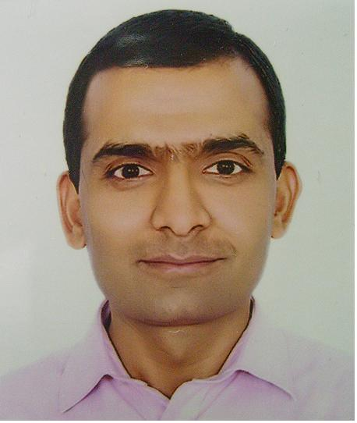
8 | Phone | : | Work | Home
8 | Phone | : |  | 044-43036359
9 | Mobile | : | 9566002948
10 | E-Mail | : | Hari.thapliyal@gmail.com
11 | Communication Address | : | B2F, Castles Wind Apartment  166, Velachery Main Road  Velachery, Chennai
12 | Education | :
- MBA (Operation)
- MCA (Computer Application)
- PG Diploma (Finance Management)
- B.Sc. (PCM)
- PMP
- MCITP
13 | Current Employer | : | Freelance PMO, EPM Consultant & PMP, MSP Trainer
14 | Designation | :

15 | Professional Experience |  |  | :
Aurovision Pvt Ltd May 2006 to Jul 2009 AVP Delivery
Pyramid IT Consulting May 2005 to May 2006 Project Manager
Cache Computer Systems Apr 2002 to Apr 2005 Project Manager
AMSYS Infotech, Noida Feb 2001 to Oct 2001 Project Manager/Lead
Hi-Fi Tradecom (P) Ltd Feb 1999 to Feb 2001 Project Manager
Hardmen Inc. Dec 1993 to Nov 1998 Programmer/Project Lead

- Technology Leadership- SharePoint, MS Enterprise Project Server, MS Visual Studio
- Responding to RFP and write EPM & PMO proposals. Helping sales team in winning sales, conducting demo, developing POC
- Conduct PMP, FPA, PMO, ISO, ITIL training
- Conduct EPM, MSP tool based training
- Delivering PMO solutions using MS EPM tools
- Organizational resource capacity planning & demand management
- Strengthen Project & Program Management practices in my organization
- Writing Project Plan & Define/Implement Project Processes
- Managing deliveries with team of project managers, architects, DBA, business analyst and IS Managers.
- Executing Fix bid projects in Agile Methodology
- Understand, define, develop systems for internal process improvements
- Internal Auditor for Delivery & Support functions
- ATM (Assessment Team Member) for CMMI L3 assessment of the organization
- Requirement understanding, maintaining WBS & traceability for project in verticals like Banking, Securities, Finance, NGO, Staffing, Mutual Funds, GIS
- Define & design dashboards for senior management, program manager, project manager
- Setup a Project Management Office, institutionalize Project Management Best Practices
- Evaluating, developing and implementing software systems to support the process automation
- MR for ISO and CSO for ISMS
- Responsible for customer satisfaction
- Define and Monitor the SLA of support functions
- Owner of organization assets library and knowledge base
16 | PMI Leadership Experience |  |  | :
- AVP Volunteer Development with PMI Mumbai Chapter
- Ex-Vice President- Volunteer Development with PMI Mumbai Chapter
- Ex-Chair of Ethics Committee of PMI Mumbai Chapter
- Member of PMI Mumbai Chapter
- Member of PMI Chennai Chapter
- Member of PMI (Project Management Institute) USA
17 | Public Speaking Experience |  |  | :
- More than 30+ PMP training session (group size varying from 8-26)
- PMPClub meeting speaker (group size 70 people)
18 | Honors and Awards |  |  |  | :
- Maintenance of PMIMC’s SharePoint portal
- Managing of PMIMC email accounts
- Developing process repository
- Initiated activities for ISO 9001:2000
- Helped PMIMC getting Component of the year award-2009
- Developed Volunteer Development Guide for PMIMC volunteers
- In PMIMC helped MPSTME to develop course as per the PMI guidelines to get the PMI accreditation.
19 | Books & Articles Published |  |  |  | :
 | Till now didn’t plan or thought in this direction
20 | Interviews Delivered |  |  |  | :
 | Till now didn’t plan or thought in this direction
21 | Other Details if any |  |  |  | :
22 | Time Commitment for Board Activities |  |  |  | : | 10 hours/ Week
23 | Goals for the Chapter |  |  |  | : | - Make sure that volunteer requirement database is published and updated and no chapter initiatves dies because of lack of volunteers  - Effective communication with volunteers  - Keep volunteers motivated  - Recognize the efforts of volunteers
 | Date | : | 15-Aug-10
 | Place | : | Chennai |  |  | SIGNATURE  Application form submitted via email.

